DEPARTMENT OF ECE

NETWORK ANALYSIS AND SYNTHESIS

{UE21EC242A}

SALLEN KEY BAND PASS FILTER

TEAM

TEJAS VP (PES1UG21EC910)

ANKUR PANDEY (PES1UG21EC048)

AKASH BHAT (PES1UG21EC025)

AIM

To construct Sallen ky band pass filter using op-amp

WHAT IS FILTER

It is sometimes desirable to have circuits capable of selectively filtering one frequency or range of frequencies out of a mix of different frequencies in a circuit. A circuit designed to perform this frequency selection is called a filter circuit, or simply a filter.

TYPES OF FILTER

1) LOW PASS FILTER

2) HIGH PASS FILTER

3) BAND PASS FILTER

4) BAND STOP FILTER

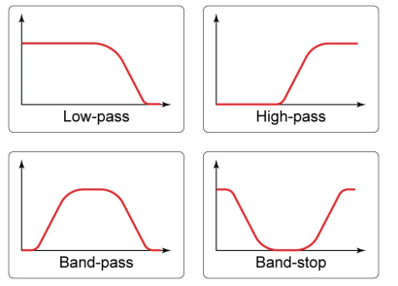

INTRODUCTION

Sallen-Key is one of the most common filter configurations for designing first-order (1 st-order) and second-order (2 nd-order) filters and as such is used as the basic building blocks for creating much higher order filters

SALLEN KEY BAND PASS FILTER

The Sallen-Key low pass filter consists of an active component—an op-amp—as well as passive components such as capacitors. RC components control the frequency response characteristics, whereas the op-amp is responsible for the voltage amplification and gain control. The figure above shows a Sallen-Key low pass filter. The op-amp in the amplifier can be used either as a unity gain buffer or a non-inverting amplifier. Sallen-Key low pass filters are the most popular second-order active low pass filter. The design of Sallen-Key filters is similar to voltage-controlled voltagesource (VCVS), with filter characteristics such as high input impedance, good stability, and low output impedance. When the op-amp is used as a non-inverting amplifier, the output voltage amplitude can be varied by controlling the gain of the op-amp. The voltage gain of the Sallen-Key low pass filter is always greater than unity, with a non-inverting amplifier op-amp configuration

DESIGN

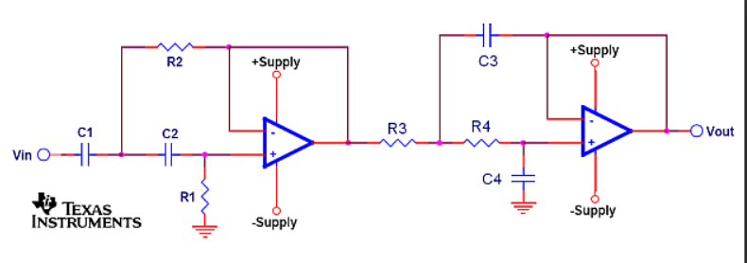

CIRCUIT DIAGRAM

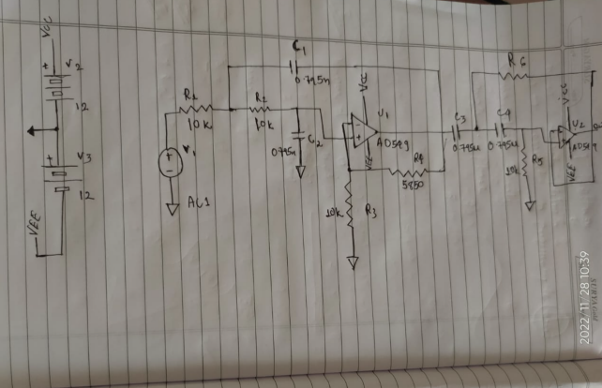

SIMULATION

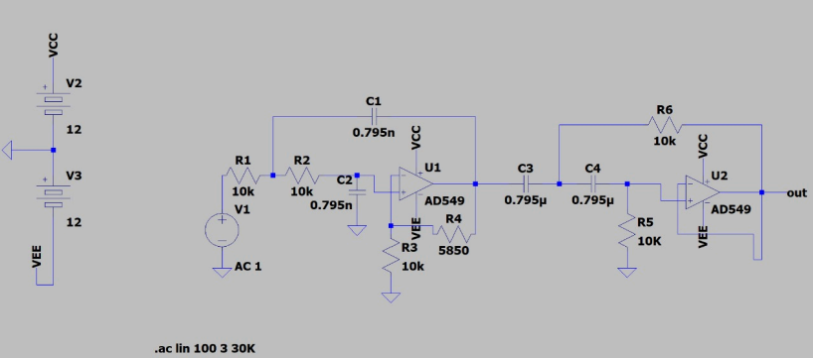

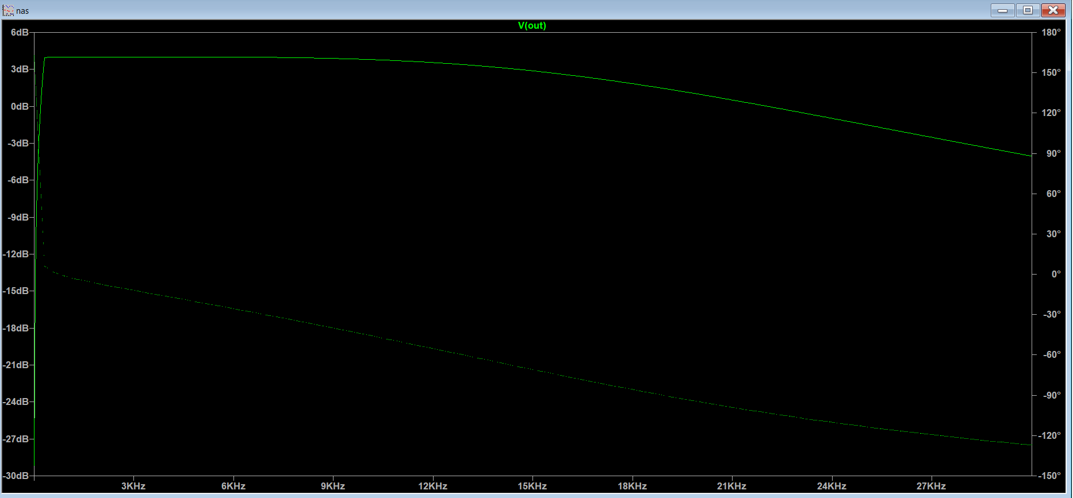Output graph

AT 20 Hz

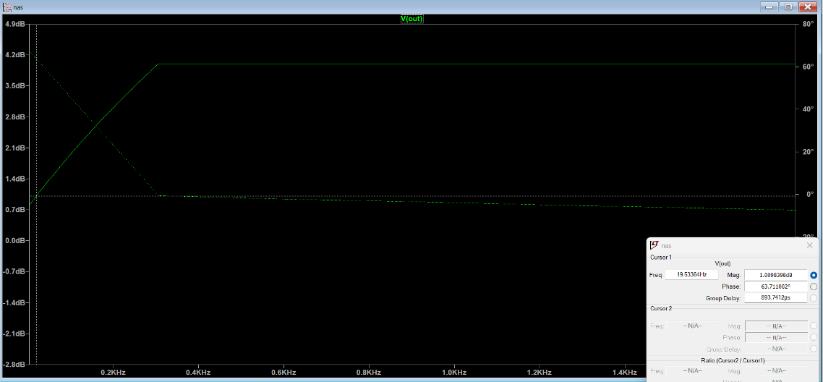

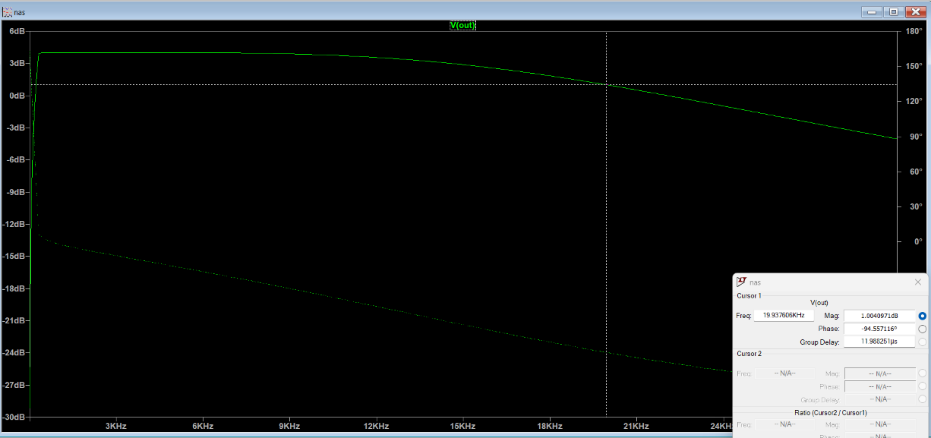At 20KHz

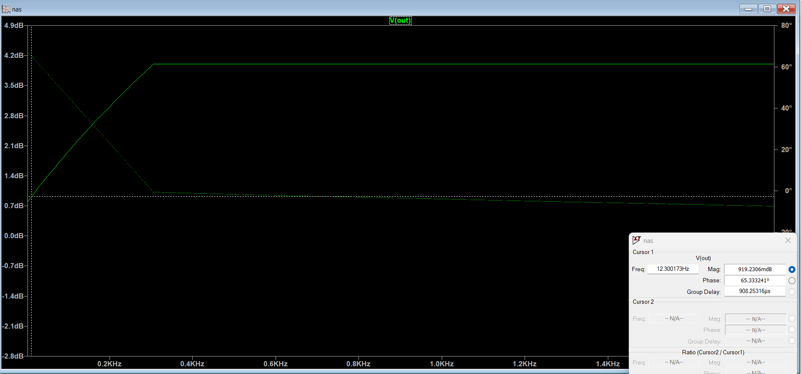BELOW 20Hz

Above 20KHz

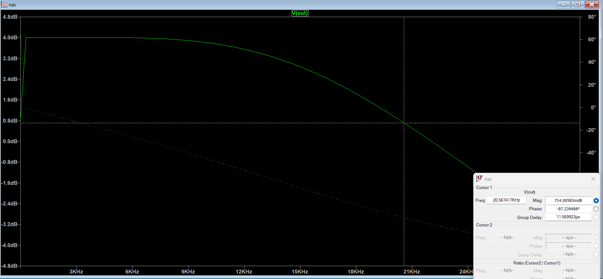

CALCULATION

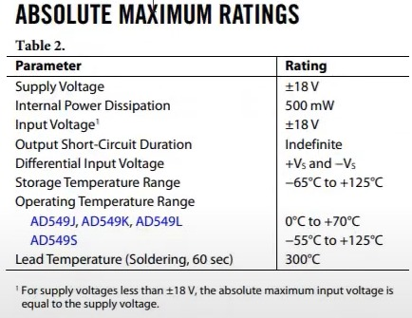.

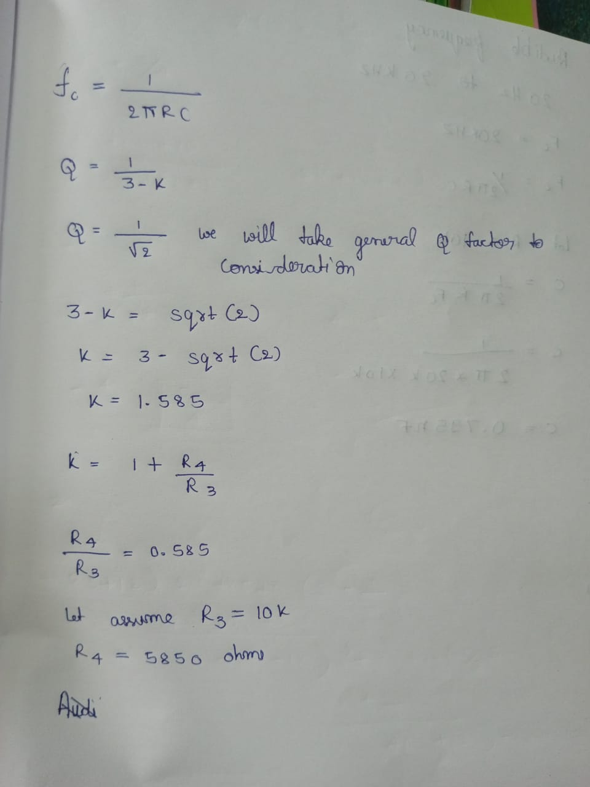

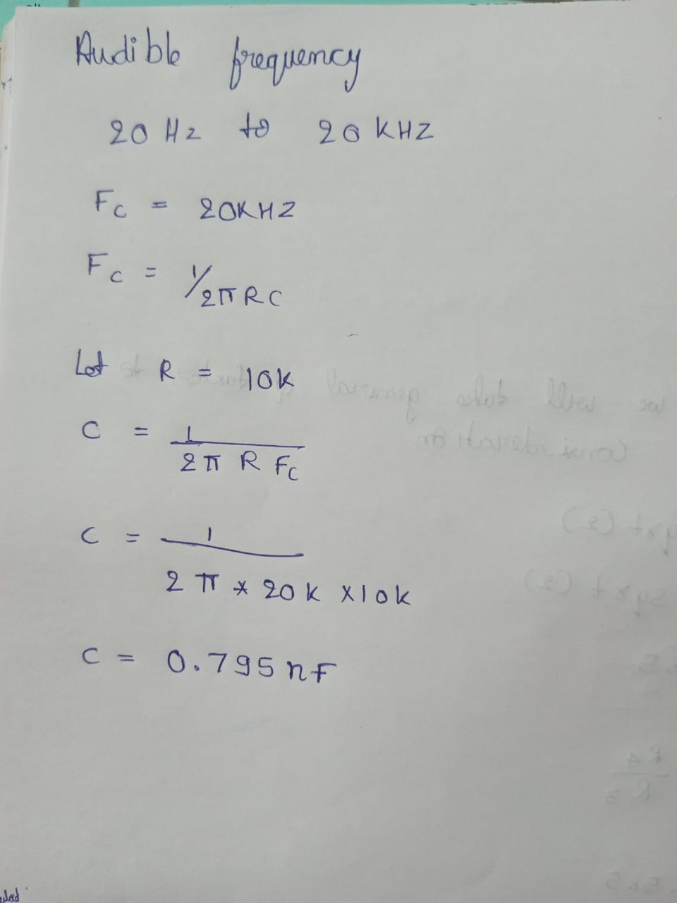

APPLICATIONS

The applications include: They are widely used in wireless transmitters and receivers in signal processing.

The main function of this filter is to restrict the bandwidth of the o/p signal that is allocated for transmission.

It evades the transmitter from meddling with other stations.

It decodes signals from a particular range of frequencies while stopping signals from unwanted frequencies to pass through. It also enhances the signal to noise ratio and sensitivity in a receiver environment.

They are deployed in all kinds of electronic and communication devices, biomedical devices like EEG’s, electrocardiograms, seismology etc.

It is popularly used in optical field too, like Lasers, LIDARs, etc.

It is used in finding meteorological data to understand the weather forecasts during a particular range of time. For example, finding out weather report of specific area from a time range of 3-10 days time period.